1. Let’s discuss the approach 2.
2. Now in this 2nd approach, instead of having 6 virtual users for 6 times login script execution, we will use just one virtual user and that virtual user will execute the login script 6 times.
3. 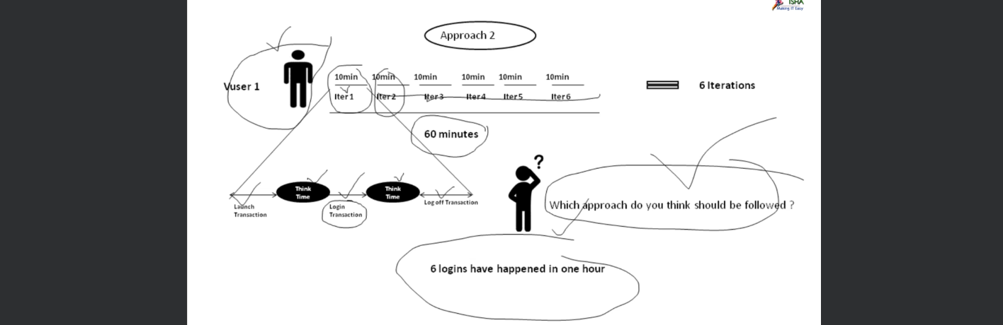  
   Remember our interest of line was only login transaction which was to be executed 6 times in one hour (which we called peak hour) but without lunching our browser we can not login and once we logged in, we can not leave the session open so we need to log out.   
   That is why our login script include other transactions like lunch transaction, log out transaction.   
   Also note the thin time taken b/w transactions.
4. Which Approach is the best?
   1. The idea is that use as less virtual users as we can use to get our work done.
   2. Note that if we use one virtual user and that virtual user is running login script 6 times it doesn’t mean that we are creating a different virtual user but the same virtual user is performing all the 6 iterations but each time it will try to run the login script with different username.